IRIS - External Governance and Oversight

Status | Draft
Version | Draft 0.2 -> Declared final 14/5/2020
Date | 11/07/2018

Notes:
- This document laid in draft state
- It has been overtaken by events
- IRIS now reports directly to the STFC PRC (Project Review Committee). This is de facto the STFC Oversight Committee function indicated in RED below.
- Recently a discussion document has been circulated to pick up on the SAB function mentioned below.
- This document has thus been declared final for historical record.

Introduction
The IRIS collaboration has already put in place a number of internal management structures which manage day to day management and development of the IRIS infrastructure and service (these are described in brief below but are not the subject matter of this document). This document describes an additional external governance and oversight structures to address oversight of two distinct activities:
- IRIS: A collaboration of STFC eInfrastructure projects (eg DiRAC, GridPP, ALC), infrastructure providers (eg SCD, Hartree, Manchester, Edinburgh, Cambridge) and Scientific projects, experiments and facilities (eg, SKA, LHC, ISIS, …). IRIS is led by Peter Clarke (Edinburgh) and is managed through its Delivery Board (DB) and other collaboration management structures.
- A four year, £16M capital project to deliver eInfrastructure for STFC as described in a business case approved by BEIS. SCD has budgetary control of this project, but acts as a custodian of the funds which are delivered through its university and facility partners. SCD issues grants and funds on the basis of recommendations received from the IRIS Delivery Board.
Whilst closely coupled, these are distinctly different activities, one is a project with fixed funding and fixed duration, the other a collaborative activity, with many partners seeking to deliver an integrated eInfrastructure for STFC. Both of these activities need governance and oversight which it is recommended is carried out through two separate entities as described below.

Proposed IRIS Governance and Oversight
Based upon STFC’s Project management Framework It is proposed that two governance and oversight committees are formed:
- An SCD eInfrastructure Project Board, chaired by the Director of SCD as Project Sponsor ensure appropriate financial and project management of the 2018 BEIS capital allocation of £16M in order to meet the business case approved by BEIS. This body will meet monthly and reports through STFC’s existing standing committees.
- An IRIS Oversight Committee, (with independent chair - ???????) reporting to SeIGO to ensure that this activity meets the needs of STFC’s science community, follow best practice and offers good value for money. The IRIS Oversight Committee will also act as an Advisory Board to the SCD eInfrastructure Project Board.
This proposed structure offers a number of key benefits:
- Responsibility for Project Sponsorship and oversight of the BEIS capital allocation rests with the budget holding department (SCD) as recommended in the project management framework.
- Oversight of IRIS’s broad einfrastructure development activities will appropriately rest with SeIGO without SeIGO needing to address short term financial / project / operational issues that instead fall to the Project Board.
- The Project Board will be able to exploit existing STFC best practice and routinely report to a number of STFC entities (such as the Project Review Committee, Risk Assurance Group and Financial Management Meeting) who exercise oversight and control across a range of STFC projects and activities.
- Through appropriate representation on the IRIS Oversight Committee (and through SeIGO) both Program’s Directorate (PD) and national Labs facilities will be able to monitor and ensure that the needs of their science communities are being met by IRIS.
- Through the presence of independent eInfrastructure experts, the IRIS Oversight Committee will be able to provide advice and assurance that IRIS is following best practice, consistent with UKRI aims and objectives.
- When required, External independent peer review can be initiated either by SeIGO or by its IRIS Oversight Committee

Background

IRIS Management Structure
Since the award of the £16M BEIS capital allocation in April 2018, IRIS has built on and replaced pre-existing UKT0 management structures (such as the UKT0-PMB) put in place to manage the original 2017 Program Directorate £1.5M capital grant.
As IRIS is a collaboration of existing STFC eInfrastructures, wherever possible, IRIS will exploit management structures and capabilities of its partners rather than create its own additional processes.
The proposed IRIS management structure was considered and developed at the IRIS(then UKT0) Collaboration meeting in March 2018 and agreed by a newly constituted IRIS delivery Board (DB) in May. Several of the core IRIS management committees are already formed and are routinely meeting. The table and diagram below describes the current status of IRIS management.

Entity | Description | Status
Delivery Board (DB) | The DB is the IRIS body responsible for coordinating delivery of the eInfrastructure required to support the STFC Science activities. The DB will ensure resources are deployed and managed optimally to meet the requirements of all STFC science activities. Broad, representative membership from: existing eInfrastructures (GridPP, DiRAC, ALC...), Data Intensive activities (eg SKA, EUCLID, LHC), Infrastructure providers (eg SCD, Hartree), attendance by others (eg Chair CAP) | Chair: Project Director (Clarke)  Status: Active  Freq: weekly  ToR: Exists
Technical Working Group (TWG) | To ensure that the UKT0 meets the technical needs of its experimental community in order to deliver real benefit to STFC’s science community. Membership open to any collaboration member. | Chair: Technical Director (Sansum)  Status: Active  Freq: weekly  ToR: Exists
Resource Scrutiny and Allocation Group (RSA) | The RAC scrutinises the resource requests from user activities, and recommend allocations to the DB. | Chair: Yates  Status: Forming  Frequency: Quarterly?  ToR: No
Science Advisory Board (SAB) | The SAB is represents the end-user science projects/activities/users across STFC Science. Its role is to provide guidance to the DB on the eInfrastructure needs of the science users and provide the DB with feedback on “real world” experience of the IRIS infrastructure. Representative membership by project and experiment scientists. | Chair: TBC  Status: No  Freq: 6 monthly  ToR: Yes
STFC Oversight Committee | IRIS identified the need for external oversight, which is the subject of this paper | See proposal above

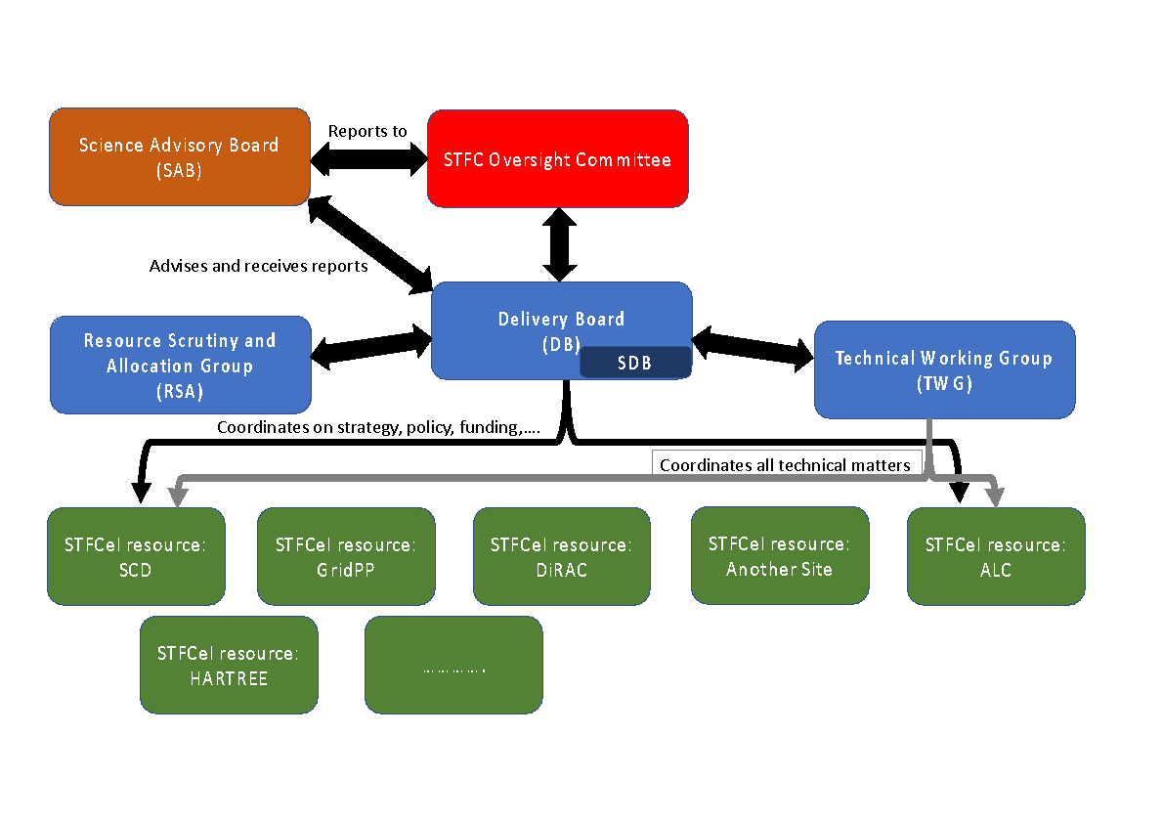

STFC Project Management Controls

Entity | membership | Frequency | Role / ToR
Risk Assurance Group (RAG) | Representation from All STFC departments | Quarterly | To support and oversee risk management in STFC and embed within operational activities. Monitors  corporate and departmental/operational  risks through review of department risk registers
Project review Committee | PRC membership comprises senior experts from each STFC Directorate and relevant departments. | Monthly | Provides regular reports to the STFC's Operations Board on the status of the major projects within STFC summarising key issues or risks identified within each project and the proposed mitigation action being taken in a “Traffic Light” report format. The PRC is also responsible for maintaining the Project Management Framework and will review this on an annual basis.
Finance Meeting | SCD and Finance department staff | Weekly/Monthly | Weekl
SeIGO | Broad representation across STFC, including programs, national labs, Diamond, CAP and independent external members | Bi-Monthly | To share information on STFC e-infrastructure requirements, to identify priorities and coordinate investments and operations. Be responsible for advising EB on the development, monitoring and implementation of the STFC e-infrastructure strategy, taking into account the importance of influencing, and aligning with, the UKRI e-infrastructure strategy. Ensure that STFC e-infrastructure activities add value for the UK research and innovation communities, and do not duplicate services from other providers. Coordinate e-infrastructure investments and activities to deliver the STFC e-infrastructure strategy. Ensure that appropriate oversight and monitoring procedures are in place to ensure that e-infrastructure funded and/or delivered by STFC, delivers against the priorities and needs of the users. Drive efficiencies in e-infrastructure operations across projects and research areas funded and supported by STFC, sharing and implementing best practice across STFC and its communities.

