UKT0 Organisational Structures

Status | Draft -> Final
Version | Draft 2.0 -> Final
Date | 14/04/2018 -> Final 14-05-2020

Notes
- This laid in draft status until may 2020
- It has now been declared final as a historical record of the discussion that took place at the time
- It is to be superseded by an up to date description document on the website.

Section 1: Introduction

This document summarises the UKT0 organisational structures
This existing eInfrastructure is the federation of several already existing well proven components providing for subsets of the science sectors. Details are given in Annex-A. Consequently, the project starts from a very well developed knowledge base and more than a decade of experience of delivery of large scale compute to science. Effective governance and management structures are therefore already in place for constituent components, and are maximally leveraged by UKT0.
In the following we describe:
- The Project Delivery Board (DB)
- The Scientific Advisory Board (SAB)
- The Technical Working Group (TWG)
- [The Resource Scrutiny & Allocation body (RSA) → see separate document]
The assumed relation between these, the host sites, and the STFC oversight committee is shown in the figure at the end of the document.

Section 2: Delivery Board
The DB is the body responsible for coordinating delivery of the eInfrastructure required to support the STFC Science activities.
It is comprised of:
- Leads from major service delivery sites;
- Those with computing provision responsibilities for the major data intensive activities;
- Those with computing provision responsibility for National Facilities;
- Technical leads.

It is important to note that the DB is not a representative body for each and every project/activity (that is the function of the SAB) (the DB would become unworkable if this became the case). The DB is the coordination body of those with responsibility to provide resources for those projects/activities.

The DB remains flexible to respond to common sense. The DB may invite any other person with just cause to attend long or short term as makes sense.

It is likely that the DB will meet ~every two weeks in the early stages. This will be reviewed after the first 6 months of project commencement.
The DB membership Table is given in a separate document.

ToR:
- To coordinate the UKT0 e-Infrastructure, ensuring that resources are deployed and managed optimally to meet the requirements of all STFC science activities;
- To create and monitor milestones and deliverables to achieve the above, and to ensure that that adequate monitoring of such takes place (in particular to monitor delivery from hosting sites receiving funding);
- To manage the UKT0 budget;
- To make funding allocation decisions;
- To select hosting sites for provision of services;
- To ensure avoidance of duplication, and standardisation where appropriate;
- To report to, and to take and act upon advice from, the Scientific Advisory Board (SAB);
- To report to and receive feedback from the (presumed) STFC-Oversight-Committee;
- To prepare and submit future funding requests;
- To engage with relevant external bodies, such as the UKRI eInfrastructure Group, other UK NeI bodies, European bodies, activity specific bodies;
- To deal with any problems as they arise;
- To evolve these ToR in the light of experience and need.

Possible Standing Sub-Group of the DB: the SDB
At the UKT0 f2f the notion that the DB may still be too big for those on it to meet regularly was discussed.
If this is so, a proposal to solve this was to identify a sub group of the DB (call it the SDB for Sub group or Standing group)
These would be people who can and will meet ~ weekly if needed.
The DB may then meet in full monthly
This need for this will be explored once the DB is set up.

Section 3: Scientific Advisory Board (SAB)

The SAB is represents the end-user science projects/activities/users across STFC Science.
The SAB will advise the DB.
The SAB will be comprised of:
- Members representing each of the compute-large PPAN projects;
- Members representing aggregates of compute-smaller PPAN projects and activities;
- Members representing the science users of each of Diamond, ISIS, CLF, CCFE. These should include members representing the Directorates of each of the Facilities;
- Member representing other National Labs. Science not covered by the above (e.g. RAL Space).

The SAB will likely meet two or three times per year.
The Chair and deputy Chair of the SAB will rotate around the scientific communities. In general one will be associated most closely with PPAN and one with the National Labs.
SAB members would likely be academic scientists, but who understand the computing infrastructure and issues in their domain.

ToR
- To provide guidance to the DB on the eInfrastructure needs of the science users;
- To receive reports on service delivery metrics, and feedback to the DB on the goodness-of-service for each science area;
- To receive and comment upon reports from the DB on any other relevant matter;
- To receive and comment on the resource scrutiny and allocation process (RSA) (see separate document);
- To consider and endorse any requests for decisions brought to it by the DB;
- To provide a report to the (presumed) STFC Oversight Committee (OSC) for each of its meetings;
- To take any further action it deems fit to ensure support of the science;
- To organise production of any science cases as required for making cases for future funding .

Section 4: Technical Working Group

Technical Working Group (TWG)

To ensure that the UKT0 meets the technical needs of its experimental community in order to deliver real benefit to STFC’s science community.
Membership will be open to all members of the UKT0 collaboration (including contractors where appropriate). The chair of the UKT0-TWG will be nominated by and report to the UKT0 iPMB. While membership is open to all, the chair in consultation with the iPMB will specifically identify a core team consisting of:
- Technical leads for each of the main experiment user communities
- Members of the software development teams working on UKT0 funded software
- UKT0 site admins, E-Infrastructure service providers and others with relevant expertise in E-Infrastructure provision in the national and international arena.
- Where appropriate members of partner projects such as GridPP and DiRAC working in the same technical domain.
[It has been pointed out that it will likely be appropriate to separate technical oversight from operations at a later stage. This is premature until further hardware is deployed and some staff posts become paid. The TWG will monitor this and recommend creation of an operations group (or sub group of TWG) when appropriate.]

The TWG reports to the DB.

Tor:
- To be the Technical Design Authority for implementation of an STFC National federated UKT0.
- Act as the point of reference for requirements capture from experiments and resource providers in support of UKT0 software and infrastructure design activities.
- To suggest policy relating to technical aspects of the implementation and operation of the UKT0.
- To take into account the longer term need to integrate fully into both the NeI and international E-Infrastructure such as the European EOSC
- To coordinate UKT0 integration activities between partner e-Infrastructures such as DiRAC, GridPP and Hartree Centre.
- To oversee the operation of the overall UKT0 infrastructure, reviewing capacity performance and availability against targets
- To recommend set up of an Operations Group at the appropriate time.

Section 5: Resource Scrutiny and Allocation group (RSA)

The RAC scrutinises the resource requests from user activities, and recommend allocations to the DB
The RAC function is described in detail in a separate document.

Section 6: Management Roles

Two Project Directors [100%-150% between the two]
There are two possibilities for project director configuration.
Project Director (PD) [100%] and Deputy Director (DPL) [xxx%]
Or
Two co-Project Directors (one generally from Nat. Labs. and one from PPAN)
Responsible for overall direction of the project, outward looking matters, seeking funding opportunities, ensuring processes to ensure that the project delivers, reporting to oversight,..

The Project Technical Director (PTD) [50%]
Responsible for more inward looking matters, to ensure the successful implementation of the technical Project and the cohesive operation of the different sites providing the UKT0 eInfrastructure. To ensure that processes needed to implement the project happen (via the PM)

The Project Manager (PM) [100%]
To manage day to day running (ensuing all processes take place, ensuring monitoring takes place, ensuring problems are addressed in a timely way…). This is a time consuming role, requiring a person with proper PM skills.

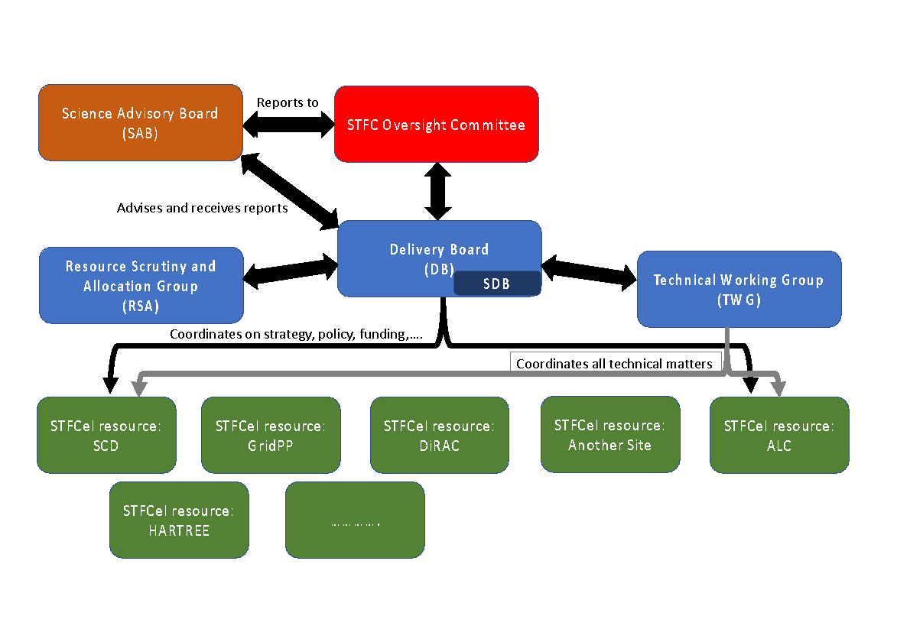
Figure 1: Organisational relationships

The Science cases for this programme (e.g. LHC, LSST, SKA,LIGO,DIAMOND, ISIS) all have science cases which are owned, peer reviewed and approved elsewhere and therefore this body should not need to have a role in owning or re-making these cases. However it probably needs to be the focus for making a joined up science case across sectors if this is needed by drawing on individual science cases.

