IRIS Organisational Structures
An update for 2020

Status | Final
Version | 2.1
Date | 22-06-2020

Section 1: Introduction

This document summarises the IRIS organisational structures

This IRIS eInfrastructure is a federation of several already existing well proven components providing for subsets of the science sectors. Consequently, the project benefits from a very well developed knowledge base and more than a decade of experience of delivery of large scale compute to science. Effective governance and management structures are therefore already in place for constituent components, and are maximally leveraged by IRIS.
In the following we describe:
- The Project Delivery Board (DB)
  - & The Project Admin Group (PA)
- The Technical Working Group (TWG)
- The Resource Scrutiny & Allocation Panel (RSAP)
- The Project Review Committee

The relation between these and the host sites is shown in the figure below.

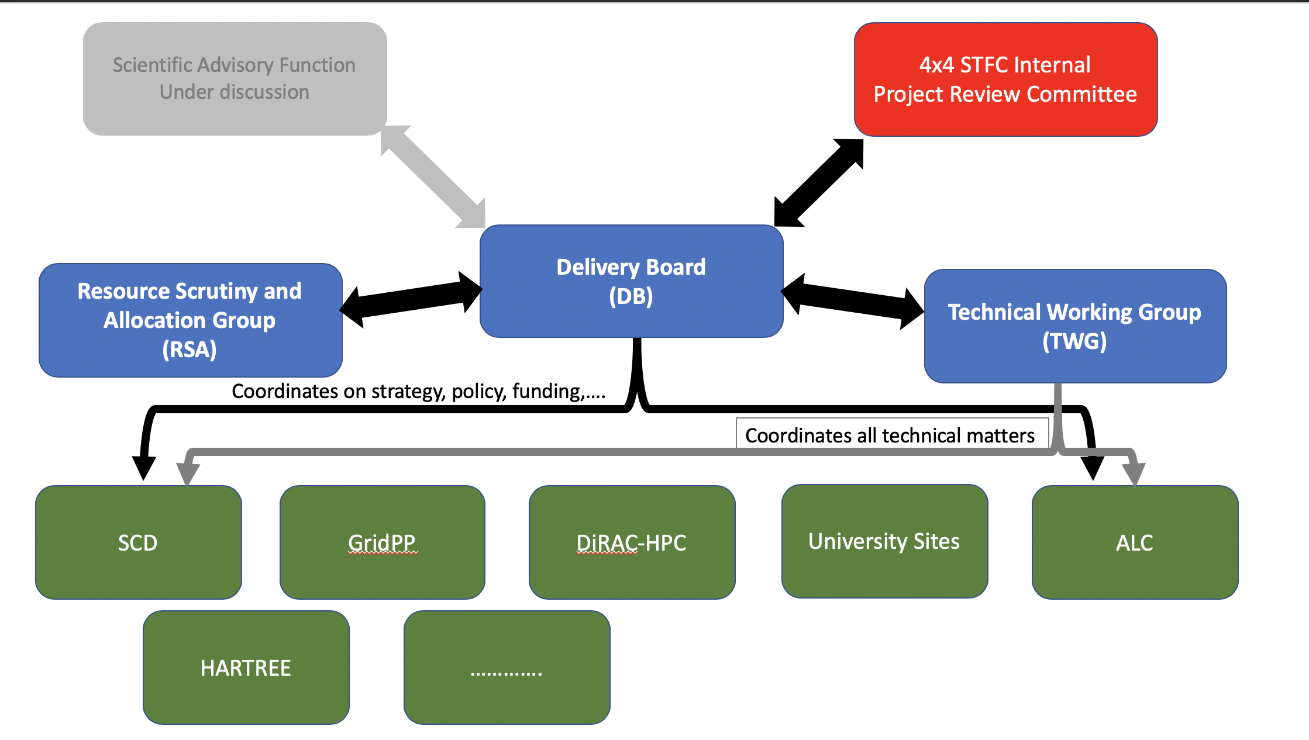
Section 2: Overview

This table shows the complete set of IRIS bodies that interact. Those most associated with Governance are highlighted in bold and described in this document

Group | Approx. Frequency | Membership | Purpose
Delivery Board | Monthly | Designated representative for all IRIS partners | Decision making body of IRIS including representation for all key stakeholders. Receives reports from all IRIS sub projects on a quarterly basis. Holds the authority to make major decisions.
Project Admin | Weekly | Project core staff | Day to day management of the IRIS project including low impact decision making
Technical Working Group | Bi-weekly | Technical staff for activities receiving IRIS allocations and providers | Discuss, present and share matters of interest to technical staff within the IRIS community.
TWG-OPS | Bi-weekly | Technical staff for activities receiving IRIS allocations and providers | Review status of IRIS allocations, services and products. Troubleshoot any current issues and encourage collaborative problem solving.
RSAP | Yearly | Specially selected panel | To scrutiniser requests for allocations and predictions of need from scientific activities. Decide which activities can be supported and set allocations. Provide an overall picture of to allow planning of spend to meet needs.
STFC PRC | Monthly | External STFC | IRIS reports to the PRC including finances and key risks
Resource Review | Quarterly | Representative from ALL activities receiving IRIS allocations | Review actual usage vs allocations to ensure maximum usage of DRI possible
Collaboration Meeting | Yearly | All stakeholders | Share status and direction of IRIS overall, discuss items of interest to the community and the future of IRIS.

Section 3: Delivery Board
The DB is the body responsible for coordinating delivery of the eInfrastructure required to support STFC Science activities.

ToR:
- To coordinate the IRIS e-Infrastructure, ensuring that resources are deployed and managed optimally to meet the requirements of all STFC science Activities;
- To create and monitor milestones and deliverables to achieve the above, and to ensure that that adequate monitoring of such takes place (in particular to monitor delivery and uptake of all funded hardware deployment);
- To manage the IRIS budget;
- To make funding allocation decisions;
- To select hosting sites for provision of services;
- To share information and intelligence and seek to avoid duplication;
- To promote standardisation where appropriate;
- To prepare and submit future funding requests;
- To engage with STFC management at all levels to make the case for continued support;
- To engage with relevant external bodies, such as the UKRI eInfrastructure Group, other UK NeI bodies, European bodies, activity specific bodies;
- To report to, and to take and act upon advice from, whatever Scientific Advisory Bodies that might be put in place (see later)
- To report to and receive feedback from Project Review Committee
- To deal with any problems as they arise;
- To evolve these ToR in the light of experience and need.

The DB is comprised of:
- Directors of the major service delivery sites;
- Those with computing provision responsibilities for the major data intensive science activities;
- Members representing aggregations of smaller (long tail) activities;
- Those with computing provision responsibility for National Facilities users;
- Technical leads;
- IRIS officers;
- Others as appropriate.

The Chair of the DB is currently the IRIS Scientific Project Director.

The DB is the highest executive body of IRIS. It is in effect a Cooperative Council. It might elsewhere be thought of as a project management body, but we avoid the word management to emphasise that it is a mutually consenting coordination body representing its members, and it does not “manage” either Provider members nor science Activity members.

The DB formally takes or endorses all decisions of IRIS. In practice this applies explicitly to the large scale spend with implications for hardware or staff resources. Some minor decisions on spend (typically ~£10k value) may be made by the PA group (see below) and then reported to the DB at the next opportunity.

At present it remains a “pragmatic” group with explicit members representing each of the Facilities and each of the large data intensive science Activities, with aggregate representation for smaller and long tail Activities. The DB is not a 1:1 representative body for each and every project/activity (the DB would become unworkable if this became the case).

The DB remains flexible to respond to common sense. The DB may invite any other person with just cause to attend long or short term as makes sense.

The DB currently meets typically every 1-2 months at the time of writing

Responsibilities of members

It is very important to keep in mind that the DB is formally a body representing the Heads of its components. Thus, its members are deemed to be, or speak for, Heads of those components.

In the case of user Activity partners this means the member is, or represents, the UK PI (or equivalent). If they are a representative then they are deemed to ensure the PI is briefed on any matter reported to the DB, and consulted in respect of any decision being taken by the DB.

In the case of Provider partners this means the member is, or represents, the Head of the computing facility (currently GridPP, DiRAC, SCD, Hartree). If they are a representative then they are deemed to ensure the Head is briefed on any matter reported to the DB, and consulted in respect of any decision being taken by the DB.

Project Admin group: the PA
The PA group is an executive working group of the DB. The IRIS officers (Directors, Project Manager, Resource Manager, Sponsor and DBs secretary) meet weekly to move forward with day-to-day matters in between DB meetings. The aim it to advance items that the DB would not wish to be brought to them in respect of every detail at every stage. Typically the PA prepares material to be discussed and approved, suggests annual spend planning budgets, plans the annual meeting, etc. The PA does not take decisions of import. Its function is to prepare material for the DB to take decisions.

Section 4: Technical Working Group
The TWG is the body responsible to ensure that, within its limits, IRIS meets the technical needs of its experimental community in order to optimise benefit to science Activities.

ToR:
- To be the Technical Design Authority for implementation of the federated IRIS eInfrastructure.
- Act as the point of reference for requirements capture from experiments and resource providers in support of IRIS software and infrastructure design activities.
- To suggest policy relating to technical aspects of the implementation and operation of IRIS.
- To take into account the longer term need to integrate fully into both the NeI and international E-Infrastructure such as the European EOSC
- To coordinate IRIS integration activities between partner e-Infrastructures such as DiRAC, GridPP, SCD and the Hartree Centre.
- To oversee the operation of the overall IRIS infrastructure, reviewing capacity performance and availability against targets
- To run the IRIS-TWG Operations Group.

The chair of the TWG is the IRIS Technical Project Director
Membership will be open to all members of the IRIS collaboration (including contractors where appropriate). Members of the TWG include:
- Technical leads for each of the main experiment user communities
- Members of the software development teams working on IRIS funded software
- IRIS site admins, E-Infrastructure service providers and others with relevant expertise in E-Infrastructure provision in the national and international arena.
- Where appropriate members of partner projects such as GridPP and DiRAC

Section 5: Resource Scrutiny and Allocation Panel (RSAP)

The RSAP receives and scrutinises resource requests from user activities, and submits recommendations to the Delivery Board for corresponding resource allocation. Its primary objective is to facilitate a fair and independent allocation of the IRIS resources to science activities within the IRIS community.

Allocations are usually carried out on annual basis for allocation of CPU, GPU, Disk and Tape resources. The Delivery Board may also request that the panel make recommendations outside the annual process and for related aspects of IRIS operations. This includes but is not limited to reviewing and making recommendations on Digital Asset Proposals.

A detailed description of the RSAP function is given in separate documents on the website.

In carrying out its primary duties the RSAP will:

- Solicit and receive requests for resources in support of science activities
- Provide formative feedback on requests prior to final submission to support the submission of high quality requests
- Scrutinize requests against a clear set of criteria relating to the validity, justification, and credibility of the request.
- Consider evidence of (in)effective use of previous allocation when making allocation recommendations.
- Submit recommendations to the DB on resource allocation
- Respond to resource requests to provide feedback and notification of outcomes.
- Provide a summary report to the DB and the data needed to aggregate the IRIS requirements.
- Review and update its membership and procedures on an annual basis.

The RSAP is comprised of:
- A Chair (chosen by the Delivery Board)
- Deputy (chosen by the RSAP) to ensure that there can be a chair of any meeting with no conflict.
- Technical Secretary
- Other officers to be determined (e.g. special function posts)
- Panel members are chosen by the Chair. The number of members should be sufficient to ensure the panel workload does not become excessive and to ensure broad coverage in expertise over the activities of the IRIS community.

Section 6: Project Oversight Committee

The STFC Project Review Committee (PRC) oversees projects delivered by the national laboratories. It provides regular (monthly) reports to the STFC's Operations Board on the status of the major projects within STFC, summarising key issues or risks identified within each project and the proposed mitigation action being taken in a 'Traffic Light' report format. PRC reports are reviewed by STFC Executive Board quarterly or more frequently as required.
A business-critical project is typically deemed to be a project over £1 million per year (or over £5 million total value) in value or where there is a high reputational or other risk to STFC. It is the responsibility of the Project Sponsor to assess the business criticality of the project based on its risk and complexity. The STFC Risk Management policy provides guidelines to undertake this assessment. The Risk Assurance will provide a second line of defence on major projects for EB and where appropriate undertake deep dives to provide necessary assurance and learnings.
The Committee Terms of Reference are:
- To meet monthly and report to Operations Board by exception;
- To monitor STFC’s major or business critical projects, and maintain an STFC Project Register;
- To maintain and develop the STFC Project Management Framework;
- To ensure there are robust mitigation plans on high level risks.

Membership: PRC membership comprises senior experts from each STFC Directorate and relevant departments.

